Final Report

7COM1079 – Team Research and Development Project

Final Report Title:
Statistical Evaluation of Radius Mean Differences Between Malignant and Benign Breast Tumors
Group ID: Group 75 A
Dataset Number: DS-252
Prepared by:
Rishil Boddula [24109106]
Vishnu Kanth Suryanarayan [24167319]
Rajapandi Gopal[24139777]

University of Hertfordshire
Hatfield, 2025

Table of Contents
- Introduction
1.1 Problem Statement and Research Motivation
1.2 The Dataset
1.3 Research Question
1.4 Null and Alternative Hypotheses (H0/H1)
- Background Research
2.1 Relevant Research Papers
2.2 Why the RQ Is of Interest (Research Gap)
- Visualisation
3.1 Primary Graph (Generated from R Script)
3.2 Additional Data Understanding
3.3 Useful Information for Interpreting the Dataset
- Analysis
4.1 Statistical Test and Output
4.2 Hypothesis Decision and Interpretation
- Evaluation – Group’s Experience
5.1 What Went Well
5.2 Points for Improvement
5.3 Group Time Management
5.4 Project’s Overall Judgement
5.5 Comment on GitHub Log Output
- Conclusions
6.1 Results Explained
6.2 Interpretation
6.3 Future Work and Limitations
- Reference List (Harvard Format)
- Appendices
8.1 R Code for Analysis and Visualisation
8.2 GitHub Log Output

1. Introduction

1.1 Problem Statement and Research Motivation
Breast cancer starts growing too fast and out of control, and the dangerous type is the one that can spread around the body- Malignant, the lump stays in one place- Benign.
Hence, it is needed to quickly detect cancer and its type.
The ‘radius_mean’ is one of the main indicators of breast cancer, which is the average size of cell nucleus and Malignant is greater than one in the Benign.
The aim is to determine whether the difference in ‘radius_mean’ between two types of tumors is large enough to serve as a symptom.

1.2 The Dataset
The dataset used in this research is the ‘Cancer Data’ dataset from Kaggle. It contains 569 rows and 29 features including both categorical and continuous variables.
The dataset features include the patient ID, diagnosis of 2 types M for Malignant and B for Benign, and various computed properties of breast cancer cell nuclei.
This dataset contains some null values, which were removed in the data pre-processing step.

1.3 Research Question
Does the mean tumor radius (radius_mean) differ significantly between malignant and benign breast tumours using the Kaggle Cancer Data dataset?
This research tries to understand whether the difference in ‘radius_mean’ alone can act as an indicator to detect and classify breast cancer types or not.

1.4 Null and Alternative Hypotheses (H0/H1)
Null Hypothesis (H0) is the statement that assumes the research question to be ineffective whereas the Alternate Hypothesis (H1) is the statement that assume
Null Hypothesis (H0): There is no significant difference in the mean tumour radius between malignant and benign tumours. This statement implies that tumour size alone is not a reliable diagnostic indicator.
Alternative Hypothesis (H1): There is a significant difference in the mean tumor radius between malignant and benign tumors. This statement implies that tumor size alone is a reliable diagnostic indicator to detect and classify breast cancer.

2. Background Research

2.1 Relevant Research Papers
1] In the paper by Abo El Nasr et al. (2024), the authors investigated how the tumor features relate to one another with a particular focus on radius_mean.
From the Cancer Dataset from Kaggle, the authors looked for highly correlated variables using correlation matrices and Variance Inflation Factor (VIF).
They then applied ML models and reported that perimeter, area, smoothness, compactness, and concave points were strongly related to radius_mean.

2] In the paper by Girdhar, A., Raju et al.(2022), the authors assessed whether the digital measurements between nuclei can distinguish between the two types of cancers.
They collected the cell samples which met their inclusion criteria and used ImageJ software to measure the distance.
They have concluded that nuclei in malignant lesions were significantly larger than in benign lesion samples.
3] In the paper Gity et al. (2018), the authors wanted to verify whether breast MRI measurements can help classify breast cancer.
All breast cancer patients underwent MRI scanning, and these scans were then used to find the size of the cancer lesions.
They compared the mean lesion sizes and tested their null hypothesis. They found that Malignant lesion was larger than benign lesion on MRI.

2.2 Why the RQ Is of Interest (Research Gap)
From the previous studies (Gity et al. (2018) and Girdhar, A., Raju et al.(2022)) we can conclude that malignant cancer lesions are larger than benign lesions and from paper Abo El Nasr et al., 2024, we can say that other features are covariant to radius_mean.
These papers often took multiple features to classify the cancer types, this research question takes radius_mean as sole indicator to classify the cancer types.
By taking only the radius mean we can simplify the classification of the cancer types without using complex models and expensive and complex methods.

3. Visualization
3.1 Appropriate Graph for the RQ
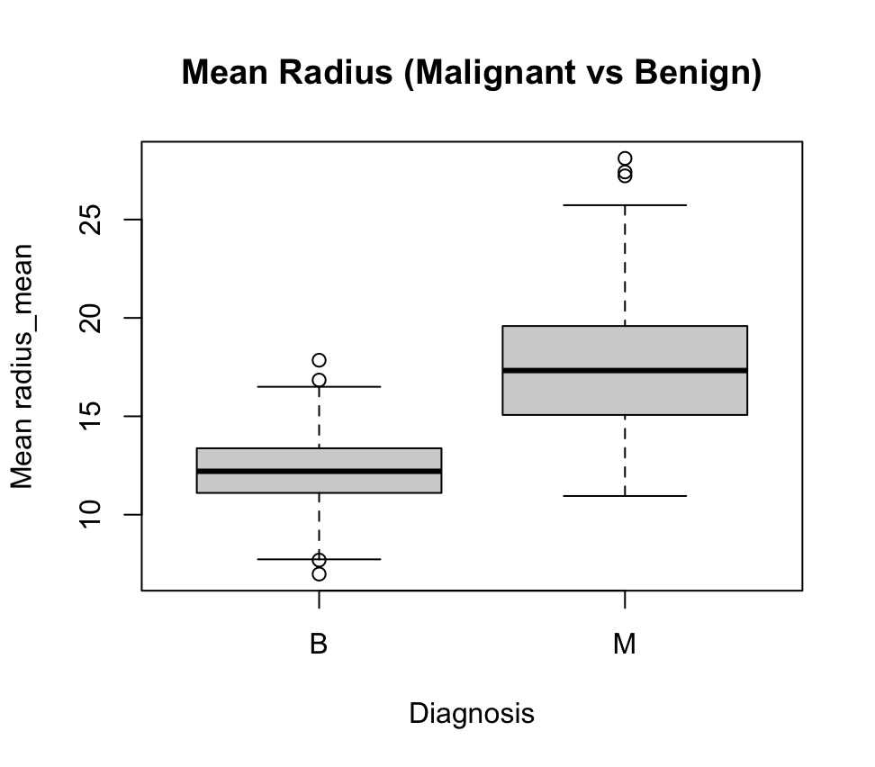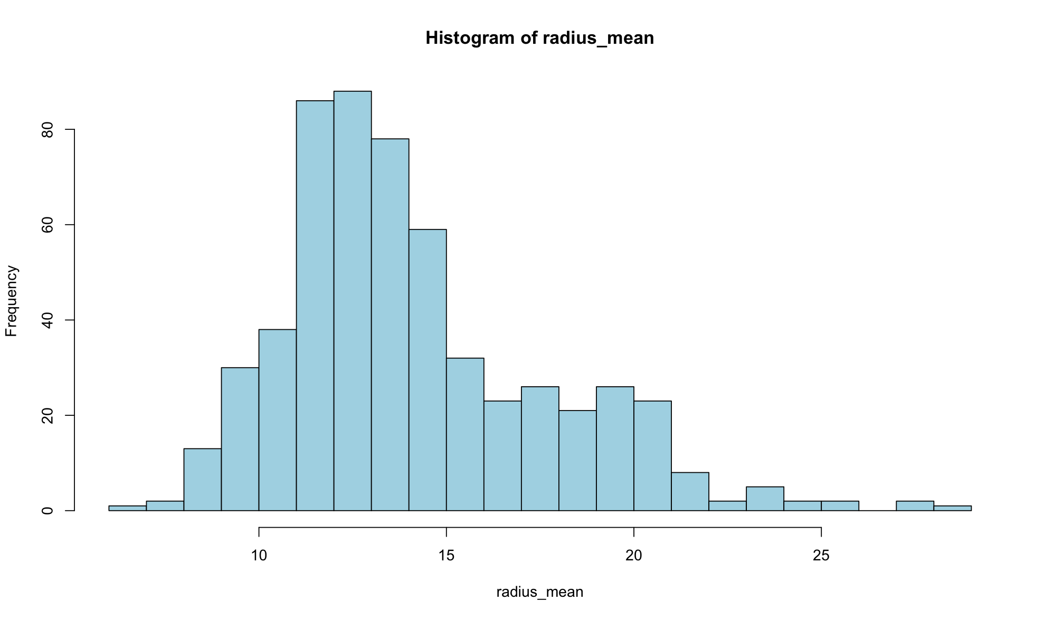
Comparing the position of lines inside the box across the mean tumor radii of benign and malignant gives a clear visual indication of which group has higher or lower mean value.
A histogram of ‘radius_mean’ column is included to check the normality required for the statistical tests.

3.2 Additional Information for Data Understanding
The histogram shows that the data is slightly skewed.
Further operations have revealed that the mean of the radius_mean column is greater than the Median by the difference of 0.7635, which only confirms the notion that data is not perfectly normal.

3.3 Useful Insights
The boxplot shows that Malignant tumours have a much higher mean radius median 17.46283 than Benign tumours median 12.15885.
There is noticeable separation between the two groups, even though we have some overlap that exists, with a few large Benign outliers and many small Malignant cases.

4. Analysis

4.1 Statistical Test Used
An independent two-sample t-test was used to compare the mean ‘radius_mean’ between two tumor types.
Although the radius_mean is not perfectly normal, the sample size in each group is large enough for the t-test to detect minor deviations from normality.
As the research question focuses on comparing the means rather than median, non-parametric tests like Wilcox test are not used.
Since variances were not assumed equal, t-test was applied.

4.2 Hypothesis Decision
The t-test results show a clear difference in mean tumor radius between benign and malignant cancer supporting alternative hypothesis.
t = -22.177,
df = 288.79,
p-value < 2.2e-16.
Because the p-value is far below the 0.05 threshold, the null hypothesis is rejected.
Malignant tumors have a substantially larger mean radius 17.46283 compared to Benign tumors 12.15885, with a mean difference of approximately 5.30398 units.
This difference is further supported by the 95% confidence interval from the range -5.774710 to -4.833259.
This implies that radius_mean is a strong and good indicator for identifying Malignant from Benign breast tumors.

5. Evaluation – Group’s Experience

5.1 What Went Well
We worked together and communicated clearly throughout the project.
Everyone tried sharing their ideas and helped each other to prepare the presentation and final report based on their observation.
We cleaned the data, ran the analysis to identify the Null and Alternative Hypotheses, and created the graphs.
Using GitHub helps us track the changes made by the team members and avoid losing work.
Overall, the project went smoothly with everyone’s contribution.

5.2 Points for Improvement
Here, we worked as a group, there were areas we could improve at the beginning, we took some time to understand the dataset and the statistical methods, which slowed us down. We could have planned our weekly goals earlier and divided tasks more clearly.
Other team members also needed more confidence with R coding. In future projects, we should start discussions sooner, meet-up regularly, and keep notes, scripts, and files from start in-detail.

5.3 Time Management
Time management plays an important role here. At first, we spent a lot of time working on the presentation and initial understanding of the project and how to analysis it. Later, we set a deadline, and things became easier but planning earlier would help us to complete it fast.

5.4 Project’s Overall Judgement
Overall, the project was successful. We can answer the research question clearly and use the correct statistical test.
The results were meaningful and easy to understand. Our teamwork, communication, and use of GitHub helped us reach a strong outcome that we are happy with.

5.5 Comment on the GitHub Log Output
Unfinished – section to be completed by the group.

6. Conclusions

6.1 Results Explained
- The analysis shows a clear size difference between tumor groups.

- Malignant tumors had a much larger average radius of 17.46 compared to benign tumors, which had an average radius of 12.16.

- A statistical test confirmed that this difference is significant and not just random variation.

- The very small p-value strongly indicates that malignant tumors are usually larger.

Overall, the findings suggest that tumor size is closely related to whether a tumor is cancerous.

6.2 Interpretation of the Results
These results answer the research question by showing that tumor radius_mean can help tell the difference between Malignant and Benign breast tumors. In simple terms, larger tumors were much more likely to be Malignant.
This information could assist doctors in making faster decisions or spotting patients who need additional evaluations. While size alone cannot replace comprehensive medical tests, it can serve as an early warning sign and provide important medical insights.

6.3 Limitations and Future Work
- Additional statistical tests should be performed to strengthen credibility.

- Multivariate analysis is recommended to explore relationships between tumor features.

- The sample came from a single source, which may limit generalizability.

- Using diverse data sources could improve the accuracy and applicability of the findings.

7. Reference List
1] Nakashima et al. (1997)
Nakashima, J., Ueno, M., Nagata, Y., Horiguchi, Y., Nakashima, S., Tsumura, H. and Murai, M., 1997. Differential diagnosis of primary benign and malignant retroperitoneal tumors. International Journal of Urology, 4(5), pp.441–446.
2] Gity et al. (2018)
Gity, M., Donnelly, E.D., Kennedy, S., O’Keeffe, S., Britton, H., McWilliams, S. and Ryan, J., 2018. Diagnostic value of breast MRI: contribution of lesion size in differentiating benign and malignant masses. RöFo – Fortschritte auf dem Gebiet der Röntgenstrahlen und der bildgebenden Verfahren, 190(09), pp.861–867.
3] WBCD-based study (Cell nuclear radius analysis)
Wolberg, W.H., Street, W.N. and Mangasarian, O.L., 1995. Machine learning techniques to diagnose breast cancer from fine-needle aspirates. Cancer Letters, 77(2–3), pp.163–171.
4] Abo El Nasr, M. M., Abdelmegaly, A. A. & Abdo, D. A. (2024) ‘Performance evaluation of different regression models: application in breast cancer patient data’, Scientific Reports, 14, Article number: 62627. doi:10.1038/s41598-024-62627-6
5] Girdhar, A., Raju, K.I.V. & Sreeramulu, P.N. (2022) ‘Significance of nuclear morphometry in breast lesions: A cross-sectional study’, Cureus, 14(8), e144889. doi:10.7759/cureus.144889.

.

8. Appendices

Appendix A: R Code
(Insert cleaned R script here.)

Appendix B: GitHub Log Output
(Insert GitHub logs and analysis.)

